Lab programs Day-11:

Name: Gopika J Reg No:192324032

1.Bellman Ford algorithm

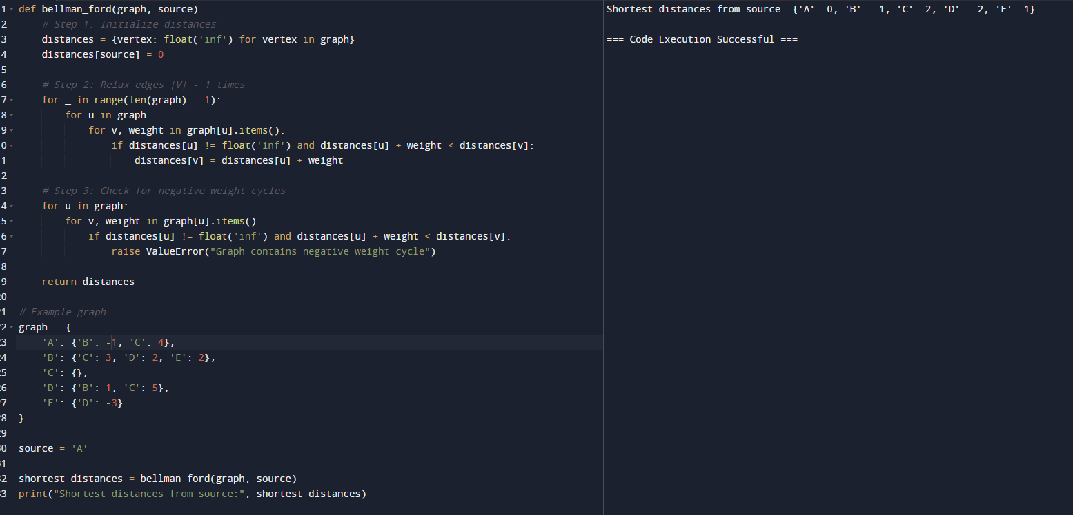

2.Warshalls algorithm

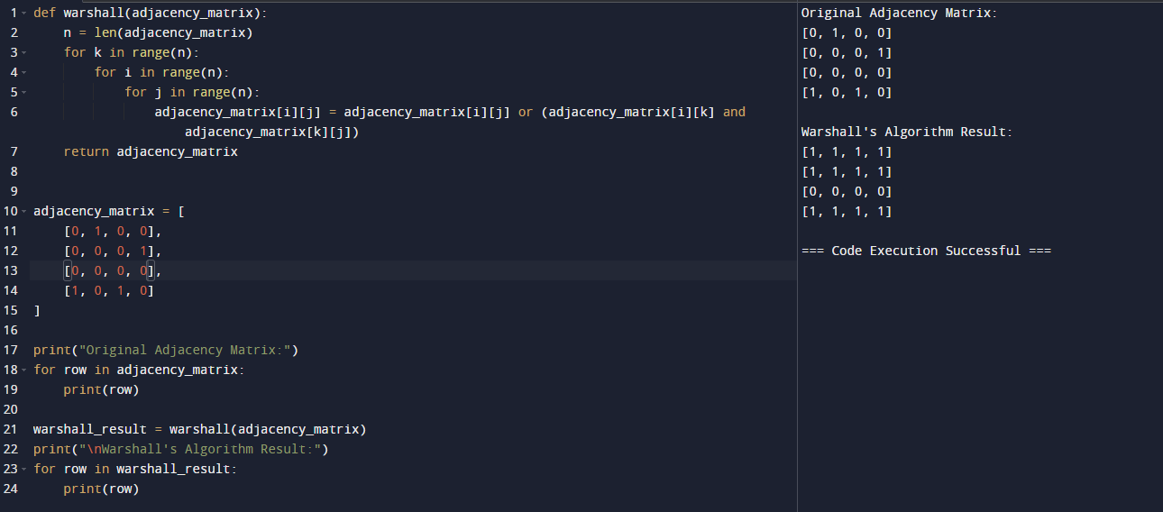

3.Coin change problem

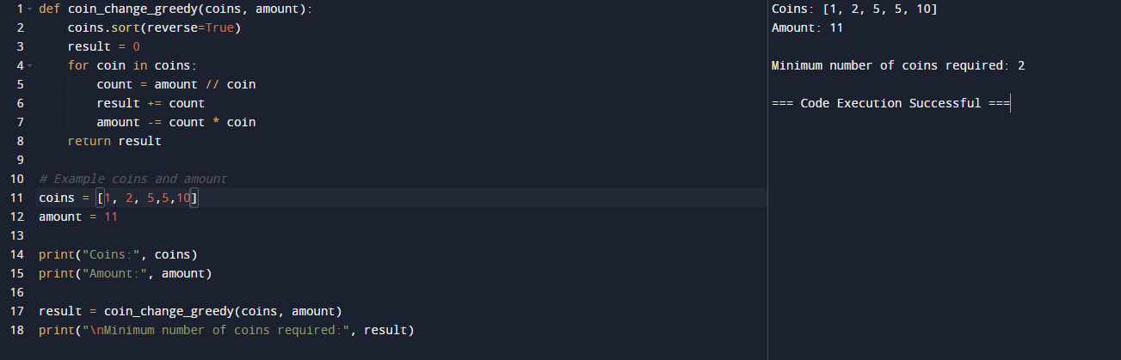

4.Knapsack problem using greedy

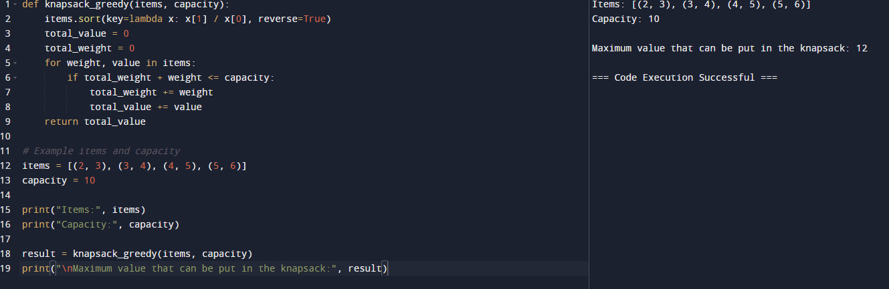

5.Job sequence with deadlines

